**ACTIVE DIRECTORY HOME LAB**

**The aim of this project is to set up an Active Directory (AD) home lab and understand the working of active directory and Windows Networking**

ADDS

RAS/NAT

DHCP **172.16.0.100-200/24**

**Internet**

**NIC 2 : Internal Network**

**NIC 1: Internet**

**Windows 2019 Server : Domain Controller**

DHCP addressing will be received from the home router

**Virtual Box Network**

**NIC 2 : Internal Network**

**Windows 10 Client**

DHCP addressing will be received from the Domain Controller

**Fig 1: Network Diagram**

* **Domain is a collection of objects with the active directory. It can contain a single user or a group, hardware components such as computers or printers.**
* **A domain tree is made up of several domains that share a common schema and configuration, forming a contiguous namespace.**
* **A namespace is a hierarchical collection of service and object names typically stored withing the DNS and AD**
* **A forest consists of several domain trees. The name of the forest is the name of the root domain or the first domain created in the forest. For instance, if x.com was the first domain created in the forest then the name of the forest would also be x.com.**

**STEPS TO CREATE THE HOME LAB**

* Download ISO images for Windows 10 and Windows Server 2019
* Create a VM in virtual box and load Windows server 2019 ISO on it. Once the installation is complete provide a password for the default admin account and then login to the server. This server will Act as our Domain Controller.
* Install the Guest Additions CD image for usability

**SETUP IP ADDRESSING ON DC**

* First click on the Network Icon on the bottom right hand corner of the screen and then clink on Network and internet settings.

* Inside the Network and Internet Settings we can see 2 Adaptors. Right click on them one by one and check the status. We can see that the first one has an IPV4 Address of 10.0.2.15 and the Second one has an Auto Configuration IP Address. Rename the First one as NAT as it connects to the home router and the second one as Internal Network

* Next we provide a class C IP Address to the internal network. 172.16.0.1/24. Here we will not provide a default gate way as the domain controller itself will serve as the default gateway. The DNS address will be the same as the ip address of the internal network or it can be the loop back address 127.0.0.1 (refers to itself)

**INSTALL ACTIVE DIRECTORY DOMAIN SERVICES (ADDS)**

* ADDS are the core functions in the AD that allow sysadmins to organize data into logical hierarchies.
* It provides services such as LDAP, Single Sign On, Security certificates and rights management.
* All access to network resources goes through AD DS, which keeps network access rights management centralized.

**STEPS**

* Open server manager and click on add roles and features
* Choose ADDS from the list of roles and proceed to install

* Close the dialog box once the installation is complete
* Go back to server manager and click on the flag icon on the top right hand corner and complete the post deployment configuration.

* Click on the post deployment configuration option

So far we have only installed the software for AD but we have not configured the domain yet. Through post- deployment configuration option we will set up the domain controller.

* In the deployment configuration dialog box click on add new forest since we do not have any domains configured. This will create a new forest a nd we can add domain trees in the forest. The name of the root domain here is **ADHL.com**

* Click next and the dialog prompts to enter a **Directory Services Restore Mode** (DSRM) password. DSRM is a safe mode boot option for windows domain controllers. It allows admin to repair, recover and restore an AD Database. Then click on next and proceed to finish

We are not creating a DNS delegation and the netbios domain name loads automatically.

* Retain the default locations for ADDS logfiles, sysvol and database

* Proceed to install the configurations

* Once the restart is complete after the installation the domain controller has been set up. We can see that our admin account has been added to the domain ADHL

Create the dedicated domain admin account instead of using the built in admin account

* Click on start🡪 Administrative Tools🡪 Active Directory Users and Computers

* Click on the domain name ADHL.com, go to new and click on Organisational Unit. We will load our new dedicated admin account in this Organisational unit

**An organizational Unit (OU) is a subsection of an active directory. We can place users, groups and other organizational units in it. It can be created in such a way that it mirrors the organisation's business structure**

* An organizational unit named ADMINS have been created under the domain ADHL.com

* We can create an admin user inside the OU ADMINS

* In the next step we set up the password for the new admin user

* Since this is a lab environment the first option is unchecked and the third option is checked. But in a real world scenario the first option would be checked and the third option unchecked.

* Right now this is a normal user account even though it resides in the admins OU. We need to add it to the domain admins group. For thet click on the user and select properties. Then go into Member of tab

* The new user is now a member of both domain admins and domain uses groups. Restart the server to let the changes take effect and then Login as the new user **a_menon**

**INSTALL RAS/NAT**

* **RAS/NAT would allow the clients on a private virtual network to access the internet through the domain controller.**
* Open server manager and click on Add Roles and Features
* Select our server (Domain-Controller)
* From the list of roles choose Remote Access and click next

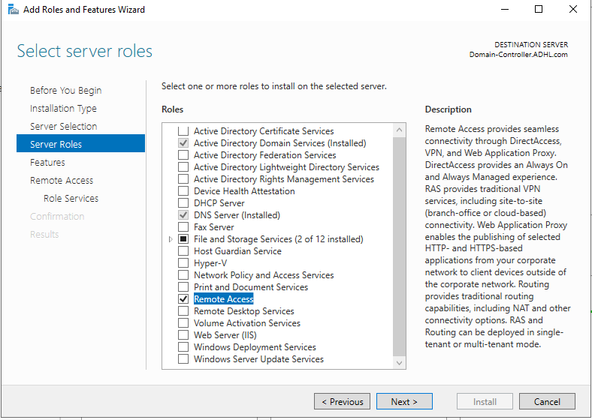

* Choose the role services from the list and click next and proceed to install
  + Direct access vpn
  + Routing

Once the role is installed we need to set up routing and remote access.

* Click on tools menu on the top right hand corner of the server manager window and choose routing and remote access option
* Click on the domain controller and select configure and enable routing and remote access option

* Select the NAT option to allow internal clients to connect to the internet through the DC’s one public IP address and click next

* In the next window we can see that the internal and external adaptor details are displayed

* Choose the NAT network to enable clients to access the internet and click next and finish the installation

**SETUP DHCP SERVER ON DOMAIN CONTROLLER**

* Click on server manager and choose add roles and features.
* From the list choose dhcp server option. Add the features and proceed to install.
* Complete the installation.

* Click on the tools menu and choose DHCP to set up the IP address

* Right click on IPv4 and choose new scope and give a name for the new scope that we are about to create.

* Specify the IP Address range and the subnet mask in the next window

* Specify the lease duration, the duration for which a computer can hold a particular IP address after which it has to request for another available IP address.
* Configure the DHCP options to allow the systems on the internal network to access the inter net. For this set the IP address of the DC as the ip address of the default router as we have already enabled routing on the DC

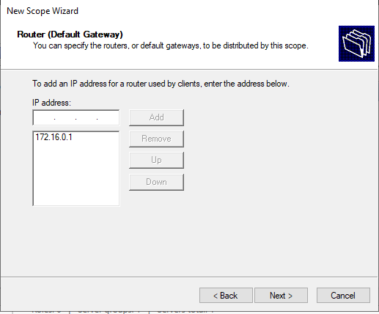

* Use the parent domain for the computers on the internal network to do DNS resolution

* Finally Activate the scope that we have created and finish the process

* Right click the DHCP server and Authorize

* Once authorization is done the server turns to green

**ADDING A CLIENT MACHINE TO THE AD**

* Create a new vm with Windows 10 OS and name it Client_1
* Choose the installation version to be windows 10 Pro.
* Before commencing the installation, set the network adaptor for the VM to internal network and also increase the number of CPUs for the system.
* Perform a custom installation.
* Since the client machine is on the internal network it has been connected to the domain’s private network and we are able to access the internet through it. IP address is as follows

* Click on start, go to system settings and choose Rename the PC (Advanced). Through this option we can join the system with the domain at the same time

* Click on the change option and provide the name of the system and the domain to which the system is to be joined.
* Use the admin account credentials to authorize the join and then restart the system to let the changes take effect. We can see that the system has been successfully joined to the domain ADHL.com. Use any of the user credentials to login.

**CREATE USERS USING POWERSHELL**

